Skin Effect in Magnet Wire
  - Abstract
This paper investigates the skin effect in magnet wire, focusing on the relationship between wire gauge and resistance per foot. A mathematical model is developed to link wire gauge with its resistance, considering the wire's geometric properties. The analysis extends to skin depth as a function of frequency, illustrating how current penetration varies with frequency changes. These relationships are integrated to establish a comprehensive model that correlates resistance with frequency across different wire gauges. Finally, theoretical predictions are validated through comparison with empirical measurements, providing a thorough understanding of the skin effect in magnet wire and its practical implications.

Notices
  - COPYRIGHT NOTICE
Published by Vito D’Erasmo, Copyright © 2024.
Unauthorized copying, in part or in whole, is prohibited without proper citation and referencing.
Created by V. D’Erasmo

  - Disclaimer of Liability
The information, observations, and conclusions provided in this document are offered as a free informational resource. All materials and information are provided "AS IS" and do not constitute professional or legal advice. No representation or warranty of any kind, express or implied, is made regarding the accuracy, adequacy, validity, reliability, availability, or completeness of the information contained in this document. Users should not use this information without independent verification and assume all risks associated with its use. Under no circumstances shall any liability be incurred for any loss or damage resulting from the use of or reliance on the information provided herein. Use of this document and reliance on its contents is solely at the user's own risk.

Table of Contents
1 Introduction 1
2 Linear DC Resistance vs. Wire Gauge 2
2.1 Deriving Area and Circumference 3
2.2 Model 1 – Skin Effect Based on a Thin Wall Model 4
2.3 Model 2 – Skin Effect Based on a Thick Wall Model 5
3 Evaluation and Conclusion 8
3.1 Comparison of Models 8
3.2 Comparison of Calculations to Measurements. 8
3.3 Conclusion. 9

List of Equations
Equation 2-1: Linear DC resistance vs. Wire Gauge 2
Equation 2-2: Wire Area as a function of Wire Gauge 3
Equation 2-3: Circumference as a function of Wire Gauge 4
Equation 2-4: Surface Resistance in Ohms per Square 4
Equation 2-5: Copper Wire Surface Resistance 4
Equation 2-6: Effective Depth of Conduction 5
Equation 2-7: Effective Conducting Wire Area vs. Frequency 6
Equation 2-8: Copper Wire Surface Resistance vs. Frequency 7

List of Figures
Figure 2-1: Linear DC Resistance vs. Wire Gauge 2
Figure 2-2: Linear AC Resistance vs. Wire Gauge for Model 1 4
Figure 2-3: Linear AC Resistance 5
Figure 2-4: Thick Wall Geometry 6
Figure 2-5: Linear AC Resistance vs. Wire Gauge for Model 2 7
Figure 3-1: Calculations vs. Measurements 8

Introduction
The skin effect is a well-known phenomenon in electrical engineering, particularly relevant to the performance of magnet wire in various applications. This effect, wherein alternating current (AC) tends to flow near the surface of a conductor at higher frequencies, leads to an increase in the effective resistance of the wire. Understanding and quantifying this effect is crucial for the design and optimization of electrical components such as transformers, inductors, and motors, where magnet wire is commonly used.

Wire gauge, which specifies the diameter of the wire, directly influences its electrical properties, including resistance and inductance. The relationship between wire gauge and resistance is fundamental to predicting the performance of electrical systems. However, the influence of frequency on this relationship, especially due to the skin effect, adds a layer of complexity that must be addressed for accurate modeling and design.

This paper begins by developing a mathematical relationship between wire gauge and resistance per foot, incorporating the geometric properties of the wire. This relationship is then extended to consider the skin depth as a function of frequency, showing how current distribution within the wire changes with frequency. By integrating these concepts, a comprehensive model is created that links resistance with frequency across various wire gauges. The theoretical predictions derived from this model are then validated against empirical measurements, demonstrating the practical applicability and accuracy of the developed models.

Through this investigation, the paper aims to provide a detailed understanding of the skin effect in magnet wire, offering valuable insights for engineers and researchers involved in the design and optimization of electrical systems.

Linear DC Resistance vs. Wire Gauge
The skin effect models the increase of resistance in a conductor as a function of frequency. There are many excellent papers and texts that cover the skin effect topic. Most of them focus on the physics behind the skin effect, however, many fall short providing practical guidance. This document will focus on practical tools instead of the physics.
The goal of this exercise is to provide a graphical representation of Magnet Wire effective resistance at various frequencies. In addition, providing the MathCad®™ worksheet will allow individuals to perform discrete evaluation at a particular frequency for a given wire size.
To that end, it is fortunate, and not well known, that wire gauge assignments are not random numbers assigned to randomly selected wire thicknesses.
The AWG assignments were made with precision and purpose.
It is no coincidence that 40 AWG copper magnet wire is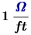 and 10 AWG is 1 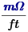

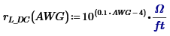
Equation 2-1: Linear DC resistance vs. Wire Gauge
The Values in the Graph below agrees with published wire charts.
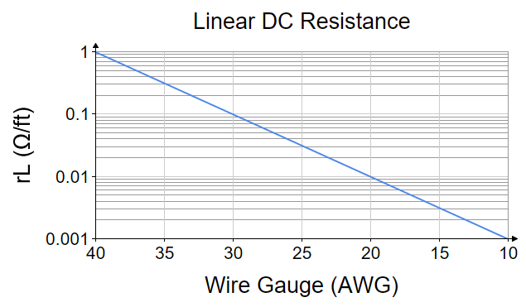
Figure 2-1: Linear DC Resistance vs. Wire Gauge

Deriving Area and Circumference
Since the resistance (per foot) is known, the area and circumference can be derived if we introduce the DC resistivity of the coper alloy used in magnetic wire.
Dividing the resistivity by the resistance per foot (Equation 1) will yield the Area as a function of wire gauge.
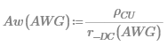
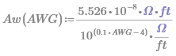
Equation 2-2: Wire Area as a function of Wire Gauge
Introducing the unit of circular mils (for area) becomes useful for comparison purposes since many published wire charts express wire area in circular mils. The term is just the square of the diameter in mils (0.001 inches).
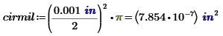
Let’s test what we have so far at a few points...

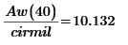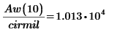
These values agree with published data. (coonerwire.com/magnet-wire)

From this the circumference can be calculated.
The circumference is related to Area by
Circumference can be written
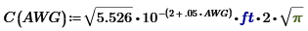
Equation 2-3: Circumference as a function of Wire Gauge

Model 1 – Skin Effect Based on a Thin Wall Model
The surface resistance of the Magnet wire copper alloy as a function of frequency is presented below.
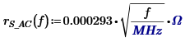
Equation 2-4: Surface Resistance in Ohms per Square
When the skin depth is much less than the wire radius, we can consider the conducting area as a thin walled pipe. We can mentally unroll the circumference into a flat plane. Dividing the AC resistance by the circumference yields the AC resistance per unit length.
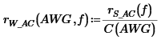
Equation 2-5: Copper Wire Surface Resistance
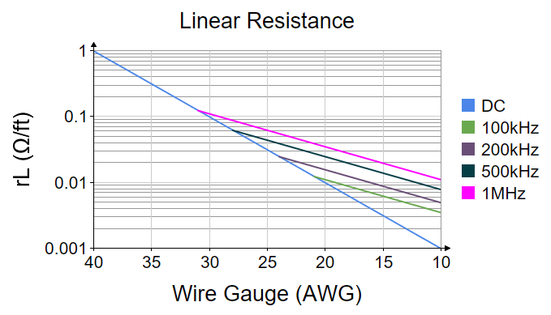
Figure 2-2: Linear AC Resistance vs. Wire Gauge for Model 1
The graph compares the DC resistance to the AC resistance at various frequencies. It is interesting to note the different slopes. The DC resistance is governed by area ( ) while the AC resistance is governed by circumference ( ). The DC slope is 2 times the AC slope when plotted on a logarithmic scale.
The result is a sharpness to the graph when the effective depth is close to the radius of the wire.
This sharpness does not exist in nature.
To address this, a different model will be considered to smoothly transition from the AC curves to the DC curve.

Model 2 – Skin Effect Based on a Thick Wall Model
When the depth is about the same as the radius, the shape of the conducting area will be a very thick walled pipe. It would be more accurate to consider the cross sectional area for this geometry. The skin depth will be needed for this analysis. This will be the resistivity of the alloy divided by the AC resistance.
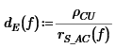
Equation 2-6: Effective Depth of Conduction

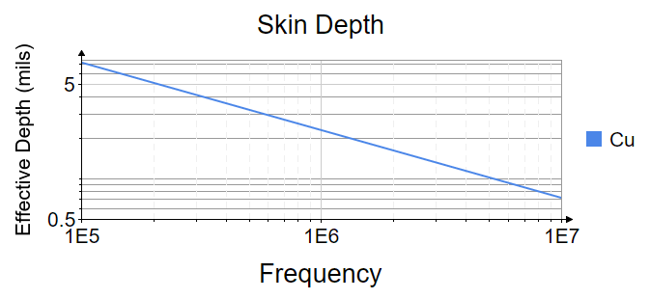
Figure 2-3: Linear AC Resistance

The resulting Area ( ) will be the area of the wire ( ) minus the area of the void ( ). The void is the area deeper than the effective skin depth.
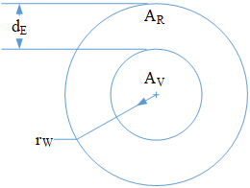
Figure 2-4: Thick Wall Geometry

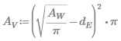
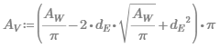
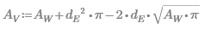
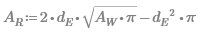
Equation 2-7: Effective Conducting Wire Area vs. Frequency

Equation 2-7 is now rewritten as a function.
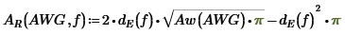
Dividing resistivity by the area will yield ohms/ft
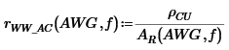
Equation 2-8: Copper Wire Surface Resistance vs. Frequency

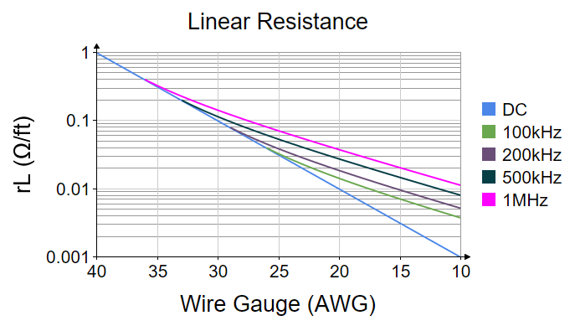
Figure 2-5: Linear AC Resistance vs. Wire Gauge for Model 2

Evaluation and Conclusion

Comparison of Models
Comparison of Model 1 (Thin wall) to Model 2 (Thick wall) yields similar results.
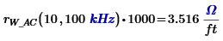
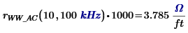
Both models give similar results when considering points far away from the intersection of the AC and DC lines. The benefit of Model 2 is that the AC curves meet the DC curve smoothly which better represents a natural process.

Comparison of Calculations to Measurements.
Measurements were taken on different wire types at different frequencies. The error is less than 5% up to 500 kHz, and 12% up to 1 MHz.
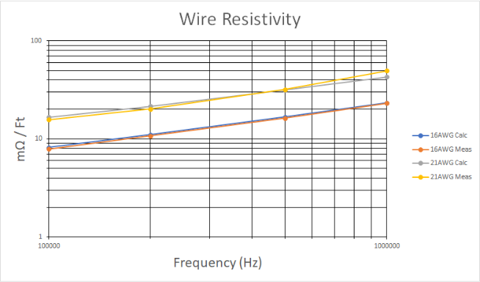
Figure 3-1: Calculations vs. Measurements

Conclusion.
Figure 2-5 provides a graphical estimation of AC resistance for Magnet wire.
It is relatively accurate for thin wall and thick wall models. Figure 2-2 is only accurate for thin wall models.

